42.18: a) 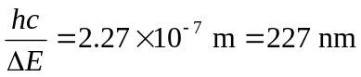, in the ultraviolet.
b) Visible light lacks enough energy to excite the electrons into the conduction band, so visible light passes through the diamond unabsorbed.
c) Impurities can lower the gap energy making it easier for the material to absorb shorter wavelength visible light. This allows longer wavelength visible light to pass through, giving the diamond color.

